**Exercise 1: Implementing the Singleton Pattern**

**//Logger.java**

package singleton;

public class Logger {

    private static Logger instance;

    private Logger() {

        System.out.println("Logger initialized.");

    }

    public static Logger getInstance() {

        if (instance == null) {

            instance = new Logger();

        }

        return instance;

    }

    public void log(String message) {

        System.out.println("[LOG]: " + message);

    }

}

**//LoggerTest.java**

package singleton;

public class LoggerTest {

    public static void main(String[] args) {

        Logger logger1 = Logger.getInstance();

        logger1.log("First log message");

        Logger logger2 = Logger.getInstance();

        logger2.log("Second log message");

        if (logger1 == logger2) {

            System.out.println("Both logger instances are the same. Singleton works!");

        } else {

            System.out.println("Different logger instances found. Singleton failed.");

        }

    }

}

**//OUTPUT**

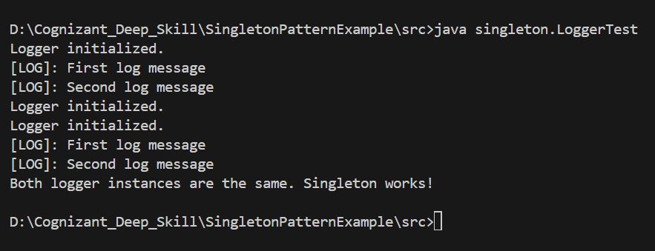

**Exercise 2: Implementing the Factory Method Pattern**

//Document.java

public interface Document {

    void open();

}

//ExcelDocument.java

public class ExcelDocument implements Document {

    public void open() {

        System.out.println("Opening an Excel document.");

    }

}

//PdfDocument.java

public class PdfDocument implements Document {

    public void open() {

        System.out.println("Opening a PDF document.");

    }

}

//WordDocument.java

public class WordDocument implements Document {

    public void open() {

        System.out.println("Opening a Word document.");

    }

}

//DocumentFactory.java

public abstract class DocumentFactory {

    public abstract Document createDocument();

}

//ExcelDocumentFactory.java

public class ExcelDocumentFactory extends DocumentFactory {

    public Document createDocument() {

        return new ExcelDocument();

    }

}

//PdfDocumentFactory.java

public class PdfDocumentFactory extends DocumentFactory {

    public Document createDocument() {

        return new PdfDocument();

    }

}

//WordDocumentFactory.java

public class WordDocumentFactory extends DocumentFactory {

    public Document createDocument() {

        return new WordDocument();

    }

}

//FactoryMethodTest.java

public class FactoryMethodTest {

    public static void main(String[] args) {

        DocumentFactory wordFactory = new WordDocumentFactory();

        Document word = wordFactory.createDocument();

        word.open();

        DocumentFactory pdfFactory = new PdfDocumentFactory();

        Document pdf = pdfFactory.createDocument();

        pdf.open();

        DocumentFactory excelFactory = new ExcelDocumentFactory();

        Document excel = excelFactory.createDocument();

        excel.open();

    }

}

OUTPUT:

